**Experiment No. 7**

**Aim:** Configure LAN and use communication and networking commands: **finger, talk, mesg, mailx, pine, telnet, ftp. Resolving of IP addresses.**

1. **finger command:**

* **Installing finger command:**

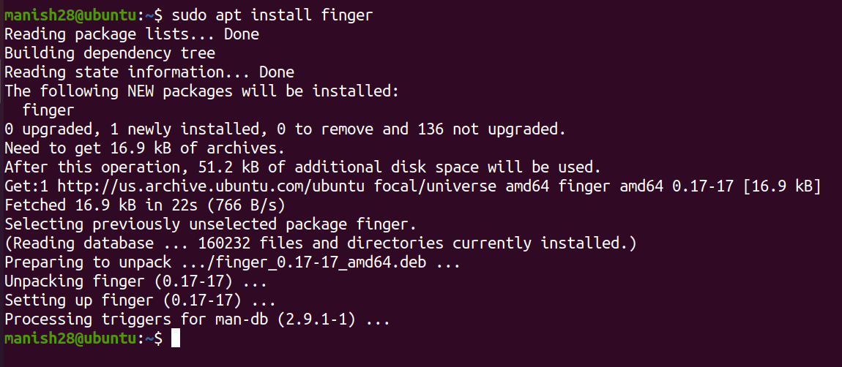

* **To finger and get details of user:**

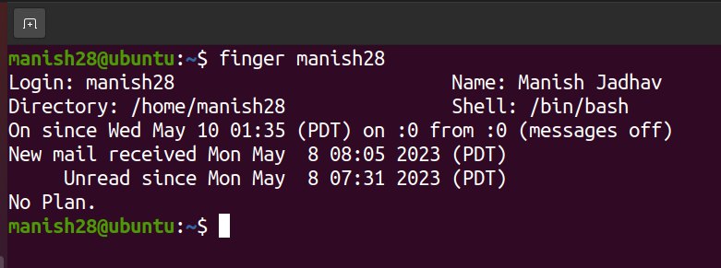

* **To get idle status and login details of a user:**

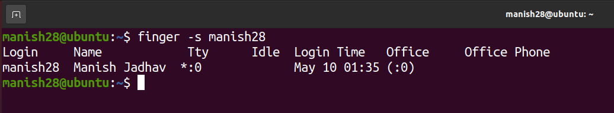

* **To avoid printing PGP key, plan and project details:**

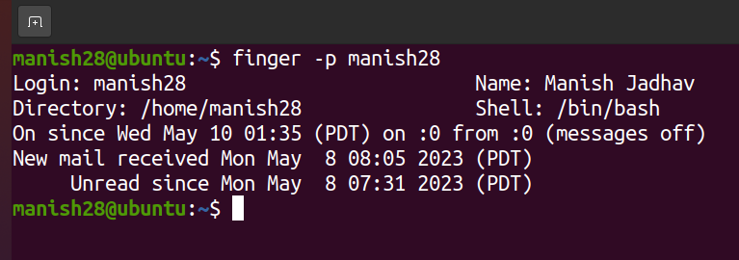

* **To create a plan for user:**

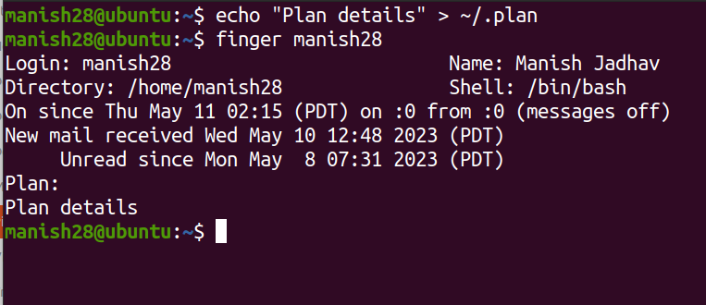

1. **Telnet command:**

* **Connecting to localnet server:**

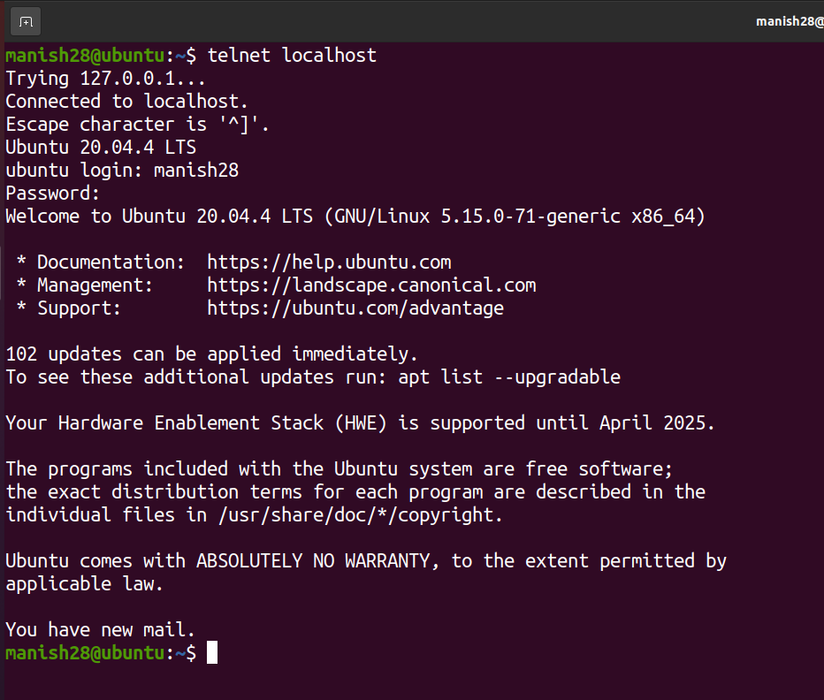

1. **mesg command:**

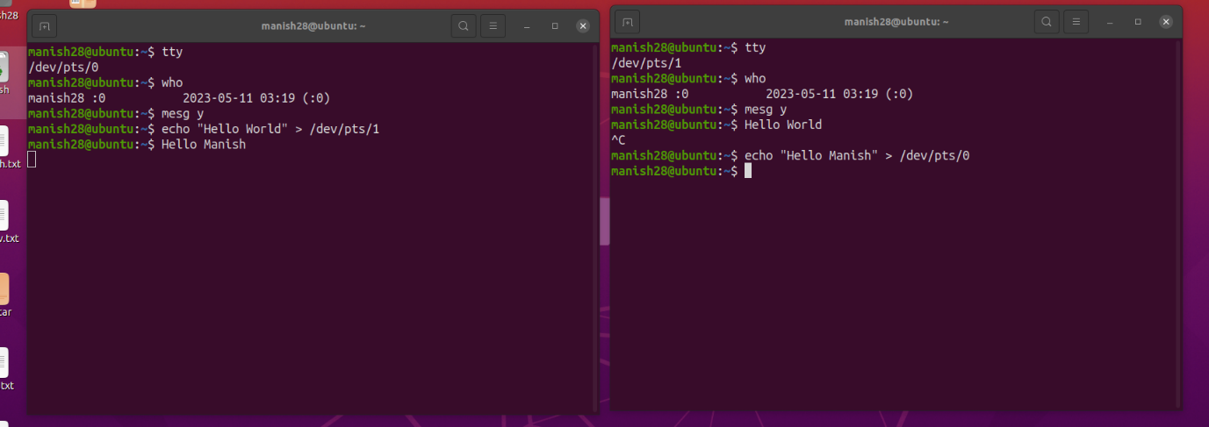

1. **Resolving of IP address:**

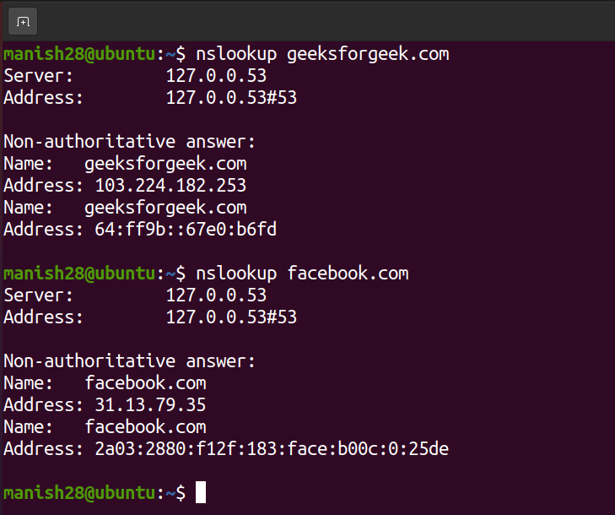

|  |  |  |  |
| --- | --- | --- | --- |
| **Practical Performance**  **(4)** | **Writeup & Oral**  **(4)** | **Attendance**  **(2)** | **Total**  **(10)** |
|  |  |  |  |